

**COMP30050 Software Engineering Project**

**Interim Report 2017/18**.

**“A creative variant on an old reliable”**

**Doctor No’s**

**Alan Doyle, 14401758**

**Joel Jacob,**

**Niall McGuinness,**

**Daniel Graham,**

**Table of Contents:**

i) Introduction

ii) Hypothesis

iii) Planning

iv) Design

* Software

v) Game Features

vi) Work Breakdown

vii) Conclusion

**Introduction**

**“Competition is always a good thing. It forces us to do our best. A monopoly renders people complacent and satisfied with mediocrity.” - *Nancy Pearcey***

Monopoly is a game where players roll two six-sided dice to move around the game board buying and trading properties and develop them with houses and hotels. Players can collect rent from their opponents, with the aim of the game being driving said opponents into bankruptcy. The game has numerous house rules and multiple editions exist; Monopoly has since become a part of international pop culture, having been “locally licensed in more than 103 countries and printed in more than thirty-seven languages.” [1]

The history of Monopoly can be traced back to 1903, when American anti-monopolist Elizabeth Magie designed a game in the hopes of explaining the evils of capitalism through a focus of the detrimental effects of concentrating land in private monopolies, as well as the single tax theory of Henry George. Magie’s original version, pictured overleaf, was originally billed as ‘*The Landlord’s Game’* was self-published, beginning in 1906.

According to an interview in 1902 by the Single Tax Review, Magie stated that her idea is “a practical demonstration of the present system of land-grabbing with all its usual outcomes and consequences. It might well have been called the ‘Game of Life’, as it contains all the elements of success and failure in the real world, and the object is the same as the human race in general seems to have i.e., the accumulation of wealth.” [2]

It is interesting to note that her role as the game’s inventor was not discovered until 1973, when Ralph Anspach, an economics professor, uncovered Magie’s patents during a decade long legal battle with Parker Brothers over his own creation of an Anti-Monopoly game. [3]

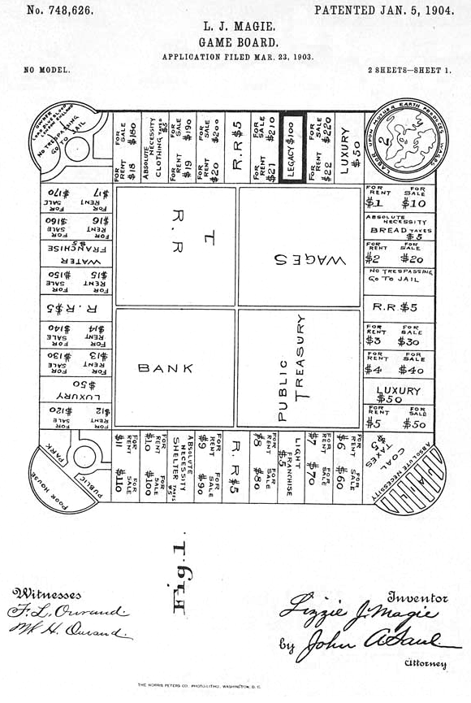

**Hypothesis**

Our primary focus upon taking the COMP30050 - Software Engineering Project 3 module was that our work and preparation in the first few weeks of the semester would be leading towards a final goal of creating our very own replication of Monopoly. This would be done through the Java Programming language, of which all of us had some degree of experience and aptitude. With varying levels of competence, it would indeed be a challenge, yet a challenge we were all more than ready for. Under direction from our lecturer, Tony Veale, we were given an idea of what exactly was expected of us over the course of this project. Using one of Tony’s extensive databases, consisting of pop culture references, we were to dynamically generate content over-laying our version of Monopoly. This would ensue the player(s) would have a unique experience each time they played, thus alluding to the name of ‘interdimensional panopoly’. Our challenge lay in the balancing of the core features and logic of the regular Monopoly, with the individual features we would choose to add so as to make our version stand out, and above all, offer a unique and exciting experience to any and all players.

# PROCEDURE

1. Lorem ipsum dolor sit amet
2. Consectetuer adipiscing elit
3. Sed diam nonummy nibh euismod

# DATA

|  |  |  |
| --- | --- | --- |
| LOREM IPSUM | DOLOR SIT |  |
| Lorem ipsum |  |  |
| Lorem ipsum |  |  |
| Lorem ipsum |  |  |

# CONCLUSION

Lorem ipsum dolor sit amet, consectetuer adipiscing elit, sed diam nonummy nibh euismod tincidunt ut laoreet dolore magna aliquam erat volutpat. Ut wisi enim ad minim veniam, quis nostrud exerci tation ullamcorper suscipit lobortis nisl ut aliquip ex ea commodo consequat.

# REFERENCES

1. https://en.wikipedia.org/wiki/Monopoly_(game)
2. http://lvtfan.typepad.com/lvtfans_blog/2011/01/lizzie-magie-1902-commentary-the-landlords-game.html
3. https://www.nytimes.com/2015/02/15/business/behind-monopoly-an-inventor-who-didnt-pass-go.html
4. Sed diam nonummy nibh euismod

Table of Contents:

INTRODUCTION

HYPOTHESIS

MATERIALS

PROCEDURE

DATA

LOREM IPSUM

DOLOR SIT

CONCLUSION

REFERENCES